**Accounting for age structure in MARK**

Where you have age classes (ie adults and juveniles) you can separate out survival by individuals captured and released as juveniles and adults.

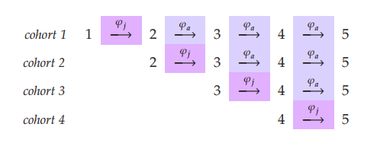

Here we have juvenile survival as φj across the diagonal (the year they were caught). If we look at this from PIM point of view we would be looking at the following parameters

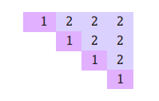In this case the model is estimating both adult and juvenile survival that is CONSTANT over time (see the same values as you transition from column to column).

Accounting for full time dependence but accounting for age structure requires you to change the PIM by both the diagonal (to account for juveniles) and by column, to account for time.

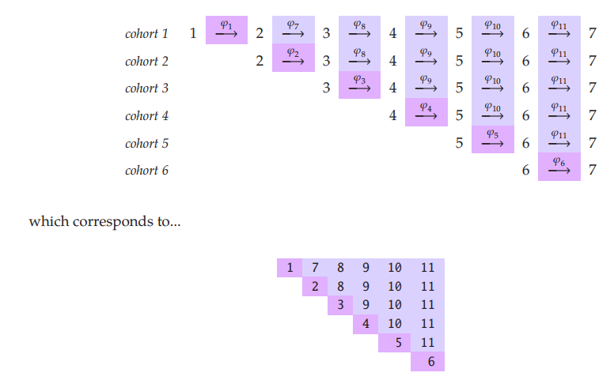

BUT SINCE BOTH JUVENILES AND ADULTS ARE MARKED WE NEED TO ACCOUNT FOR THESE EFFECTS.

You treat the juveniles and adults as SEPARATE GROUPS.

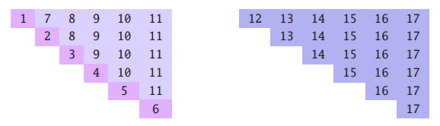

Eg. Separate PIMs with time dependence

NOTE: This is the **most general model**, even more general than the group*time models that you measure goodness of fit from.

To see if there is an effect of age we want to build a reduced model where survival when marked as juveniles after entering adulthood is similar to those marked as adults.

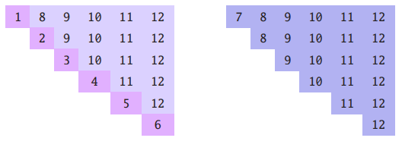

“In other words, here, we’re assuming that adult survival is the same, regardless of whether  
or not the individuals were marked as your, or marked as adults (whereas earlier, we allowed for adult survival to differ as a function of age at which the individual was marked).” (MARK book, 7-31)

After goodness of fit testing, and correcting for chat, develop a set of candidate models (based on biological expectations (are recaps the same, do we expect differences in recap/survival between some groups but not others etc).